Digital Technologies & Hangarau Matihiko 3.1

Level 3, 3 Credits, Internal Assessment

Student Documentation

This document serves as evidence of your work for **AS 91901: Apply user experience methodologies to develop a design for a digital technologies outcome**

# Instructions

Edit the header and replace the underlines with your full name and NSN (you can find this on PCSchools under Student Information).

You must attach relevant images (wireframes, mockups, screenshots, etc.) into each section of the document. You must also include a high-resolution copy of these images separately.

For your **FINAL** submission, make sure you have included:

1. Your name and National Student Number (NSN) in the header for each page
2. **ONLY** include the information you wish to have marked and moderated

Table of Contents

Instructions 1

Explain the purpose of the digital technologies outcome and the requirements of the end users 2

Explain relevant implications 5

Investigate relevant user experience methodologies 7

Iteration #1 8

Iteration #2 11

Iteration #3 14

Explain the appropriateness of a chosen design 17

Evaluate how the design addresses relevant implications 18

Justify that the chosen design is suitable for the purpose and end users 20

Justify how the chosen design might be further developed in the future 20

Appendix 21

# Explain the purpose of the digital technologies outcome and the requirements of the end users

## Purpose

Write the communicative purpose of the outcome in the field below.

|  |
| --- |
| The purpose of the website is to educate viewers on Onslow College’s cultural history. To achieve this, I will be creating a quiz site, which will allow the users to better learn and memorize said history. I will also need to implement classes that teacher accounts will be able to assign to student accounts. |

## Identify stakeholders

You need to identify your end users. Fill in the table below with the end users you have identified, including whether that person/group is a primary stakeholder (usually the project owner), secondary stakeholder, and/or end-users.

|  |  |
| --- | --- |
| **Individual/group name** | **Role (i.e. end user, stakeholder, owner, etc.)** |
| Onslow students (Y9-Y13) | Primary end users (Using site to educate self) |
| Onslow teachers | Secondary stakeholder (Utilizing site to educate others) |
| Local Whānau | Secondary end users (Also using site to educate self) |
| Other Onslow Staff | Secondary end users (Also using site to educate self) |
| Teacher | Primary stakeholder (NCEA giver) |

## Stakeholder requirements

Identify the stakeholder’s requirements through surveys, interviews, and usability testing.

Write a list or paragraph for each subheading.

## Functionality

-

## Design (visuals)

-

## Data

-

## Technological

-

## Budget

-

# Explain relevant implications

What relevant implications do you need to consider in the design of your digital technologies outcome? Explain at least three relevant implications and how they relate to your project.

## Social

-

## Cultural

* Since I will be tackling culturally sensitive education, such as local Maori History. As such, I will need to make sure that any associated information is accurate, as to not mis-educate users. On top of this, I need to make sure any cultural symbolism (Icons etc) stays culturally accurate.

## Legal

## Ethical

-

## Intellectual property

-

## Privacy

-

## Accessibility

-

## Usability

-

## Functionality

-

## Aesthetics

-

## Sustainability and future proofing

-

## End-user requirements

-

## Health and safety

-

# Investigate relevant user experience methodologies

You need to investigate and use relevant user experience methodologies to generate, evaluate, and improve your design. UX methodologies include (but are not limited to):

* user research
* usability evaluation
* information architecture
* user interface design
* interaction design
* visual design
* content strategy
* accessibility

Identify the user experience methodologies you will use. For each, justify why the user experience methodology is relevant to the outcome of your design.

## Methodology #1

I will use: User design feedback.

It will be useful because: It will help to evaluate how end users feel about selected colour schemes or fonts, and will aid in identifying any unclear aspects of the site.

## Methodology #2

I will use: Color-blindness testing

It will be useful because: It will allow for a larger target audience, as users with color-related disabilities will still be able to navigate the site effectively.

## Methodology #3

I will use: Stakeholder surveys

It will be useful because: It will help evaluate the website’s criteria and fit for purpose, by cross-referencing the website’s features with the stakeholders expectations.

# Iteration #1

Attach your website design images here. Alternatively, attach images to the appendix. Provide high-quality copies with the final submission.

## Design idea #1

Screenshot(s): -





<https://www.dafont.com/vermin-vibes-1989.font>

<https://www.dafont.com/pixeled.font>

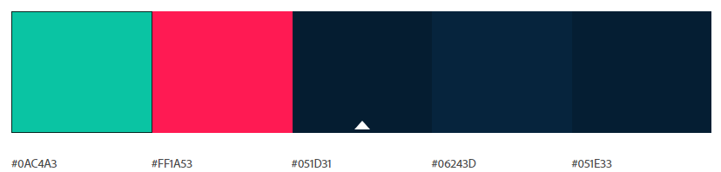

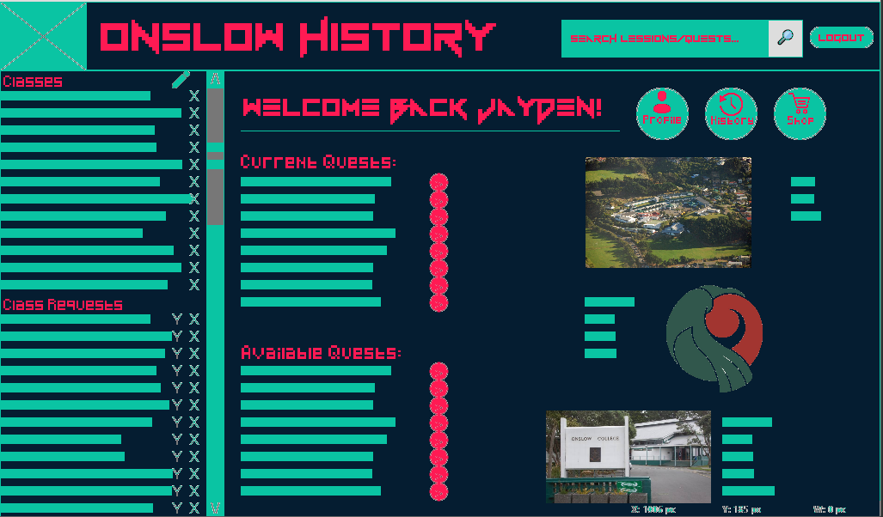

**Testing/feedback:**

**Words associated with colours:** Confident, chilled, fun, sleek, simple, interesting

**Words associated with fonts:** Interesting, fun, enthusiastic, interesting, playful, inclusive, detailed

**Words associated with overall design:** Mint, cool, cyberpunk, robotic, high contrast

**Overall design feedback:**

Background colour is great.

Too neon.

Hard to read text on green but fine on background.

Accent colour overused.

Quite dark colour

A very reddish pink colour

Text colour works well and stands out on background colour

Aqumarine tint.

The font is semi-hard to read. Easy to tell what I need to interact with, and the segments are easily distinguished.

A good combination of fonts and colours.

Make it less noisy.

Chang the sub-header or header font to show a bit more difference between each other.

Text colours are really good.

Text on background works really well as the text stands out from the darker background colour.

Bright pink accent colours are really effective.

Your colours work great together and really give the website a bright exciting appeal.

One thing that could be improved is lowering the amount of blocks of text as I think it overpowers the website. Less is more.

I like how you used red and green as accent colours as it represents the Onslow colours.

Title font formatting is horrendous in lowercase.

I like the title font and how it pops well, also the background color.

The colour combination, text on secondary combination, button colour need to be improved. Also, the background colour tint for the sidebar so be adjusted, make the x’s in the sidebar a new colour, have different font or colour for buttons.

Nice feeling of a neon display, but when there is neon text on neon secondary colour it stops working. This design might strain people's eyes. The feed section should also use a separate colour as it seems like part of the quests. Images feel out of place due to them not having a border or anything. Having more variations/shades for the green might be nice (very slight difference) or constantly changing like a neon light. Or go less intense for the user.

## Design idea #2

Screenshot(s): -





<https://www.dafont.com/fipps.font>

<https://www.dafont.com/pixellari.font>

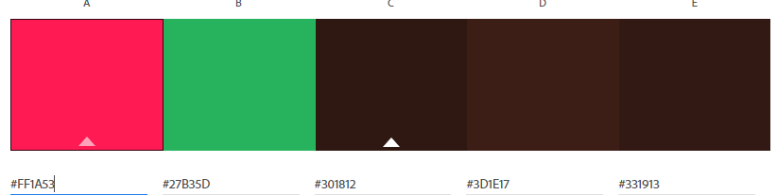

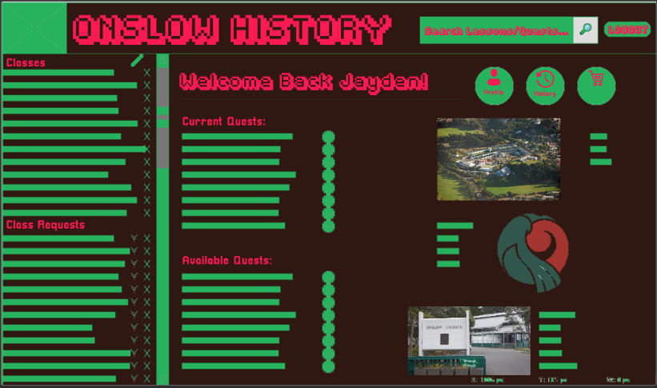

**Testing/feedback:**

**Words associated with colour palette:** Playful, sleek, chilled, sloppy, amateur, warm, childish, interesting.

**Words associated with font scheme:** Engaging, playful, fun, childish, detailed

**Words associated with overall mockup:** Muddy

**Overall design feedback:**

I actually liked the brown background. It can be hard to incorporate brown into your website but I think you did a good job and it works quite well as a background colour.

Text colour gives a massive pop to website so well done.

Text to background colour combination is all good.

Accent colours are bright and lively.

Again, just less links and words as I think this will make the user feel less overwhelmed by the website.

I really like how the fonts pop against the brown background.

Good background color. Text stands out but doesn’t mix well with background.

Aquamarine green colour doesn’t work well with the background.

Type face diversity works well.

The outline of the type face makes the header hard to read. Background colour yes.

Change font header so not as outlined, especially pronounced in the top title.

I dislike the feeling this colour (green) gives me, it feels wrong in my bones.

Good colour but maybe use the background colour of mockup 1.

## Design idea #3

Screenshot(s): -





<https://www.dafont.com/rainyhearts.font>

<https://www.dafont.com/alagard.font>

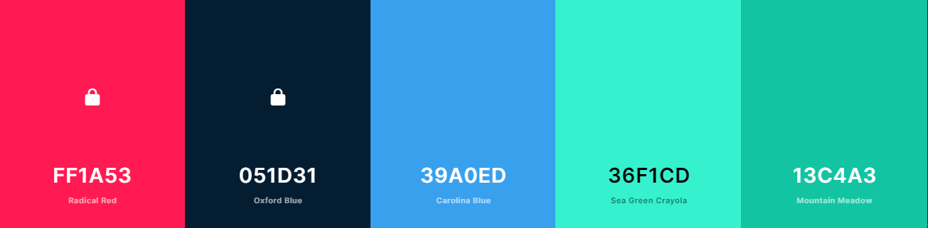

Screenshot(s):

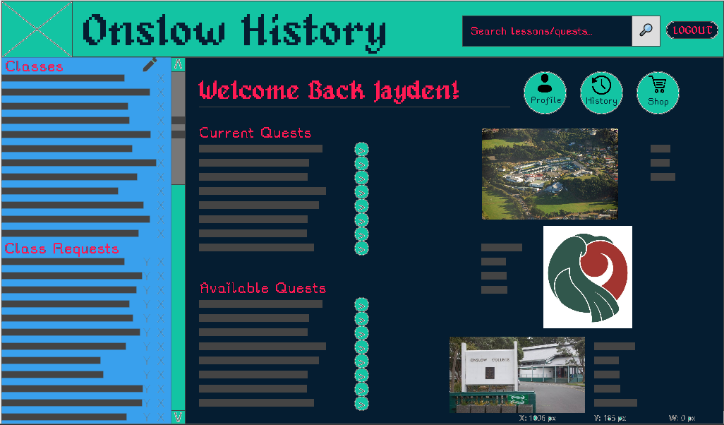

**Testing/feedback:**

**Words associated with colour:** Relaxed, Clever, Playful, Stuffy

**Words associated with font scheme:** Trustworthy, Interesting, Playful

**Other words associated with site:** Calm, Inviting

**Overall design feedback:**

Good dark colour choice.

Very adventure quest type fonts.

Nice dark colour.

Text colour stands out well, especially the background colour.

Mock-up easy to read, navigate and to identify different sections.

The colour of the words doesn’t work so well.

Has different colours to show different sections.

Change the colour of text.

Text colour gives the website some extra pop.

**Overall iteration feedback:**

I preferred mock-up number 2 overall as the colour palette was the best. However, I would change the fonts.

I preferred number 1, as it looks the most professional and has the least noise. Also has a good colour palette. However, the Mock-up has quite a lot of action going on, so maybe make it a little less noisy as to not overwhelm the user.

**Conclusion:**

From the feedback gathered, I’ve concluded that I will abandon the third mock-up. This is primarly since it wasn’t any interviewed stakeholders’ favourite choice. Also, the playful, relaxed atmosphere users felt when navigating the site didn’t match the more fun, retro and high-intensity atmosphere I am aiming for with the site. However, stakeholders liked the different colouring of the class section, so I should incorporate that into the next design. On top of this, the sub-heading font colour was well liked in the mock-up, in contrast to the previous mock-ups. As such, I should use it in place of one of the harder to read fonts from the first and second mock-ups.

**Areas to improve:**

* Improve text readability.
* Reduce mock-up noise (text, images, layout etc)
* Distinguish sections with differing colours.
* Adjust the colour palette of the new iteration, making the font on background colour combinations mix better. Also attempt to incorporate the brown, if possible, as it was well liked in the second mock-up, but the combination of colours around it was strongly disliked.
* Improve image alignment.
* Increase button visibility.

# Iteration #2

Attach your website design images here. Alternatively, attach images to the appendix. Provide high-quality copies with the final submission.

## Design idea #1

New colour scheme, inspired by the first mock-ups colour palette, but with better complementary colours by adding a very light brown tint to the reds. Also chose the more readable fonts, keeping the vermin vibes font just to the title, due to the readability difficulty issues highlighted in the user feedback. Lastly, I shifted the image to align with the text better and made the text on background colour easier to read.

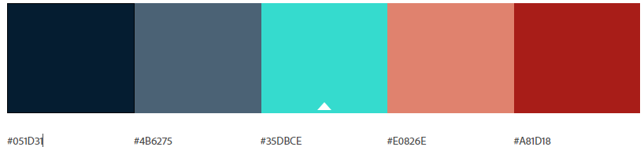

Font palette:



<https://www.dafont.com/vermin-vibes-1989.font>



<https://www.dafont.com/alagard.font>



<https://www.dafont.com/pixellari.font>

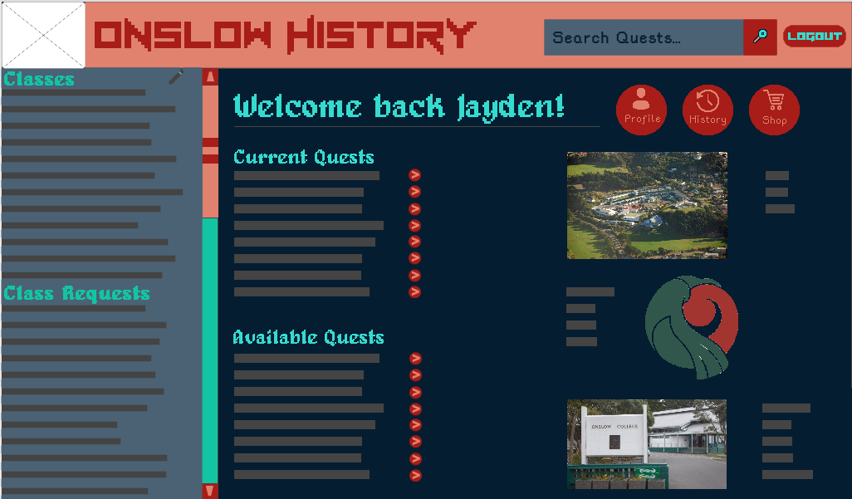

Words associated with color: Professional, Engaging, Trustworthy, Interesting, Playful, Fun.

Words associated with font: Engaging, Interesting, Confident, Detailed, Fun, Clever, Playful, Laid-back, Enthustiastic.

Overall words associated with mock-up: MMORPG

Overall feedback:

Dark blue is good, dark theme is superior.

Light blue looks good for the header, but the body text could be better.

The light blue on the dark blue contrasts well, but not so much for the red in the header bar. The body text could be hard to read on the dark blue.

Perfect font readability, easy to distinguish different interaction points and sections.

It’s unique and interesting, not something I’ve seen before.

The body text could be better.

The dark colour is really nice to see and the blue and red go really well together.

The ice blue is really nice to look at.

The bright text on dark background is really nice and makes reading the site easy.

The accent colours are very nice. The red and blue is really cool. The blue calms the user while the red gives the user encouragement.

The bright coloured scroll bar to the left of the site really helps separate the main and the side sections of the website.

“Perfect site no improvements needed.”

## Design idea #2

For the second one, I incorporated the same feedback as the first design idea, but used the second original mock-up as the base color template.

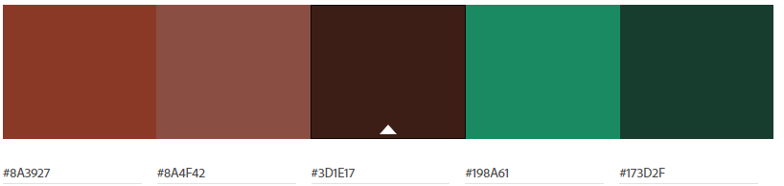

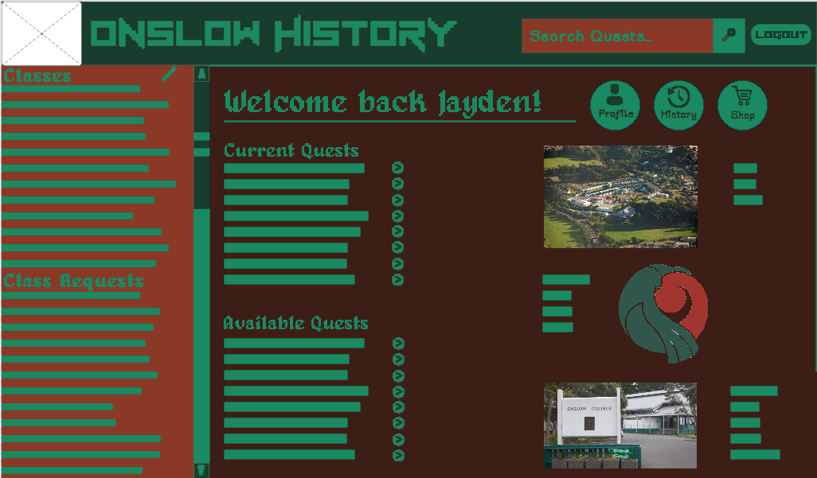

Feedback:

Words associated with colour scheme: Simple, Shambolic, Sloppy, Silly, Amateur, Enthusiastic.

Words associated with font: Engaging, Interesting, Detailed, Confident, Fun, Clever, Laid-back, Playful.

Overall words associated with mock-up design:

Minecraft Grass Block.

Overall Feedback:

“I don’t like the brown, the background looks more like a poopy brown than a reddish brown.”

The light green looks pretty good, not my favourite colour but better than most.

Despite the odd colour choice, the text and background contrast well and makes it very easy to read.

Easy to read, navigate and distinguish different sections.

“It fits the Onslow logo colours…

The Onslow logo colours suck.”

The background colour for the right side of the page is good but the left side of the page doesn’t look so good.

The text colour is okay, you could make it slightly brighter to make it stand out from the background more.

The text-on-background combination is alright, but it’s kinda hard to read cuz the colour of the text and the background both have dark colours.

The red stands out from the rest of the page, you could change it to a different colour.

It’s very compact but not so much that it’s confusing. The buttons are highlighted so the user can see what to press.

The colour scheme could be improved by changing one of the colours.

Make the font brighter.

**Overall iteration feedback:**

I liked mock-up 1 more, the colours look better. Perhaps use different tones of colours to see if it could be improved and change the grey text to be lighter to make it contrast better with the dark blue background.

I liked the first one, colour scheme is far superior to the 2nd.

**Conclusion:**

From the feedback gathered, I can conclude several things. From the general stakeholder’s feedback, the second mock-up will be removed, meaning the final mock-up will be based on the first mock-up. This is because, overall, stakeholders preferred this page, and had very few issues with it. The only issues mentioned were potential text contrast issues for the body of the page. This is something I will look at changing in the final iteration when I implement actual text instead of line indicators. Another potential issue is with the primary stakeholder, who has concerns over the readability of the side-menu for color-disabilities. As such, for the final iteration I will run the mock-up through all colour-deficiencies, to see if there are any problematic deficiencies.

# Iteration #3

Attach your website design images here. Alternatively, attach images to the appendix. Provide high-quality copies with the final submission.

For the third iteration, I decided to run it through some accessibility tests. To do this, I ran the given mock-up through a colour-blind test, testing for all types of colour-blindness. I also ran the final design by the primary stakeholder, for any final opinions.

Design:

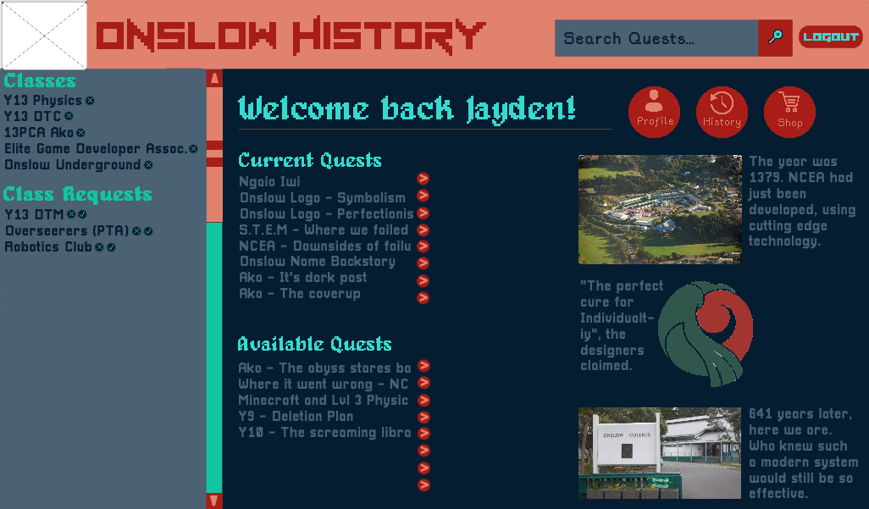

Colour-blind Results:

Deuteranomaly:

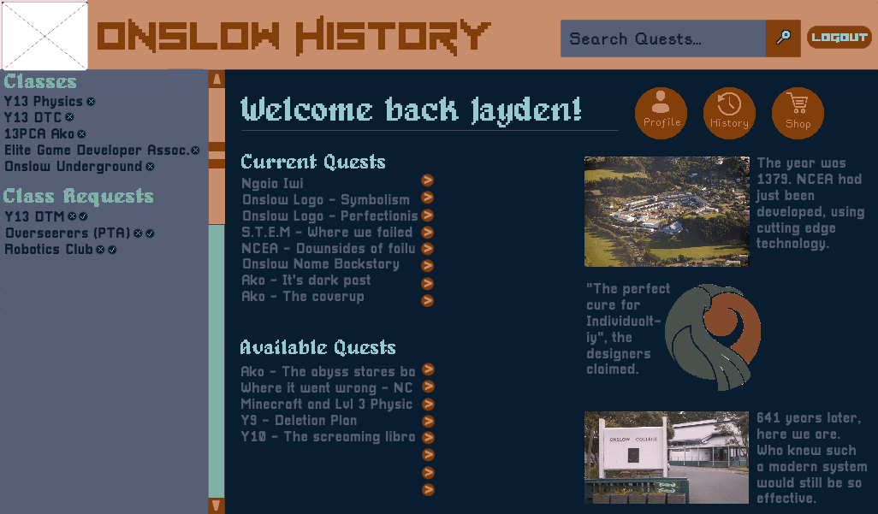

Deuteranopia:

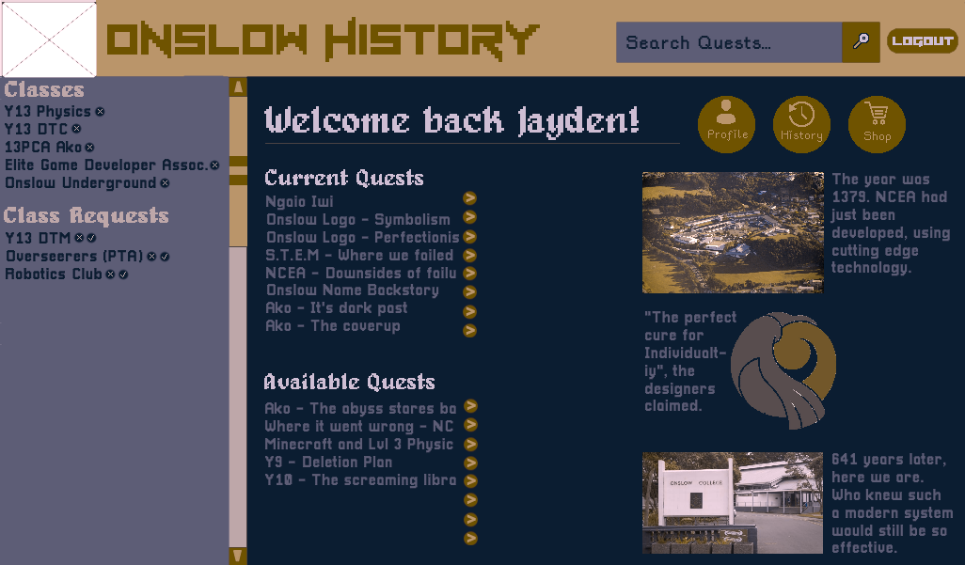

(Repeated for all colour-blind modes)

From the data gathered by colour-checking it, I’ve concluded that there are no colour sensitive issue with the site. I then got the primary stakeholder (Teacher) to review the site.

# Explain the appropriateness of a chosen design

In addition to images of the design, explain in a few paragraphs why the one you have chosen is the most appropriate design out of your generated design ideas. Link your decision to:

* User experience methodologies
* Stakeholder feedback
* Usability testing

Screenshot(s): -

I have selected this design because: -

## Evaluate how user experience methodologies were used in developing the chosen design

-

# Evaluate how the design addresses relevant implications

How does your chosen design **address** relevant implications?

## Social

-

## Cultural

-

## Legal

-

## Ethical

-

## Intellectual property

-

## Privacy

-

## Accessibility

-

## Usability

-

## Functionality

-

## Aesthetics

-

## Sustainability and future proofing

-

## End-user requirements

-

## Health and safety

-

# Justify that the chosen design is suitable for the purpose and end users

-

# Justify how the chosen design might be further developed in the future

-

# Appendix

If you would prefer to place images here rather than in each section, add a hyperlink in each section to the relevant image. This makes the document easier to navigate.

**DELETE THESE INSTRUCTIONS BEFORE YOUR FINAL SUBMISSION.**

To add an image to this section, follow these steps:

1. Add a new paragraph with the Heading 2 style (green text, underline across page). This is the title of the image. *Make sure the name is meaningful on its own. For instance, “Website design 1 homepage” or “Entity Relationship Diagram”*
2. Press Enter to move to a new line.
3. Attach the image beneath the heading.
4. Back in the relevant document section:
   1. Select some text to serve as a link.
   2. Right-click on the text, hover over the arrow next to Link. At the bottom of the list, click Insert Link.
   3. On the left, click on Place In This Document.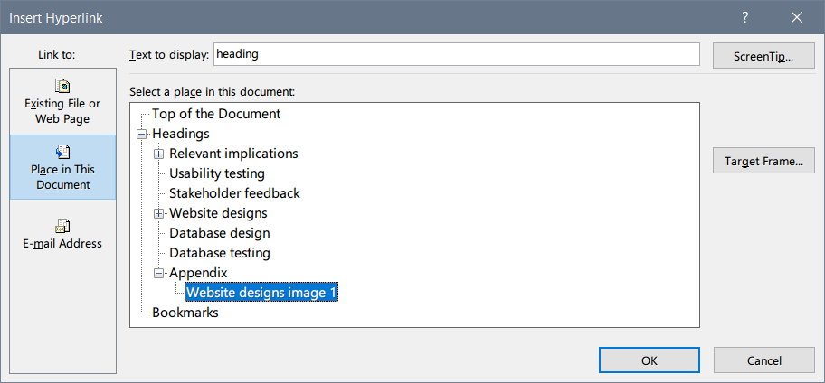
   4. Under Appendix, choose the heading you have just created and click OK.

## Example image: website designs image 1

Here is an example of a hyperlinked image. A link to it is included in the Website designs section. **DELETE THIS IMAGE BEFORE YOUR FINAL SUBMISSION**.

